**ANALYSIS OF THE ENVIORNMENTAL FACTORS AROUND THE MANESAR LOCATION**

Abstract

The objective of the study is to analyse the rapidly changing of the environmental factors due to the urbanisation and development of the land over the past years. GIS based analysis of land use pattern was done using Landsat satellite Imagery for the year 1991, 2011, 2014 and 2019. The infrastructure projects and the Immigrants population result in the increase in the settlement area over the past years. Increment in the population result in the high demand of water. Currently, the dependency on groundwater has worsen and is still decreasing with the rate of 1-1.2 meter every year. This also result in the natural vegetation and the irrigation land facilities. Also, the narrow stream lines are also a result in the scarcity of water bodies.

Keywords: Environmental, Immigrants, Infrastructure, Irrigation, Landsat, Satellite, Urbanisation

Introduction:

The Government initiative of smart city and housing for all in Delhi agglomeration area results in the rapid growth and development in the area of NCR region. The Government of Haryana has made similar attempts by initiating a concept of a planned city Manesar. The city used to be sleepy in the early ‘90s now has emerged as the fastest growing Industrial town in Haryana. It is a tehsil and part of Ahirwal region. The area has seen many changes in the land use -landcover over the past years. This major rapid development has given rise to several environmental concerns.

Location of Study Area:

It is one of the among the five Tehsil of Gurugram district and a fast-growing industrial town next to National Highway 8. The nearest railway is Ghari Harasu, Patli and Taj Nagar. The study area is spread over around 178 sq.km along the Manesar tehsil of Haryana and part of the Gurgaon-Manesar Urban Complex. The climate of the study area can be classified as Tropical Steppe, Semi-Arid and Hot which is characterized by extreme dryness of the air. During three months of southwest monsoon from the last week of June to September, the moist air of oceanic origin penetrates the area and causes high humidity, cloudiness and monsoon rainfall.

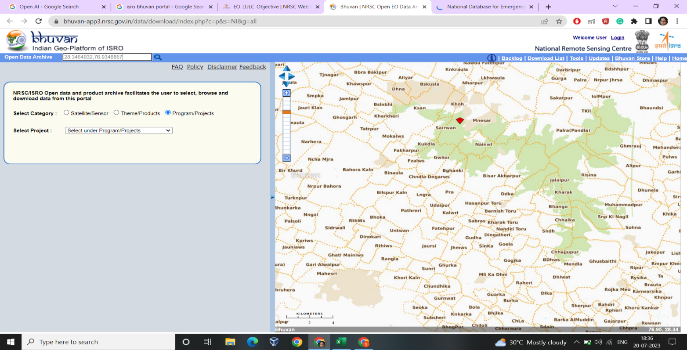

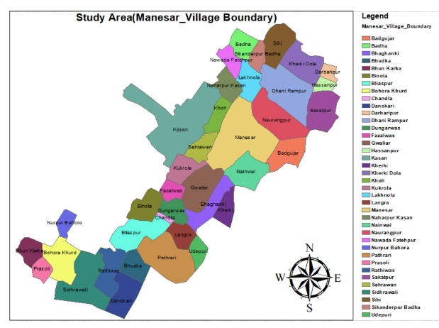



**Img (1): Satellite Image of the location (28.3464932, 76.9348857)**

Land Development:

To understand and study the changes over the land usage and pattern over the past years, a feature-wise area statistics were analysed. The increasing trend of construction area, urbanisation, irrigation of the land and various other factors were kept in mind while doing the land analysis. However the study suggests that agriculture products will be reduced further in the coming days due to land acquisition by government and development of urban complex.

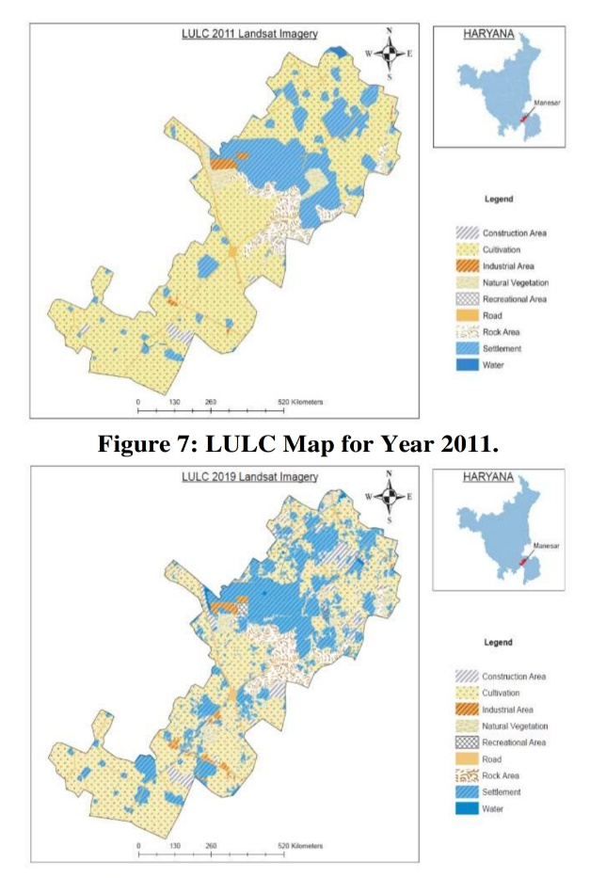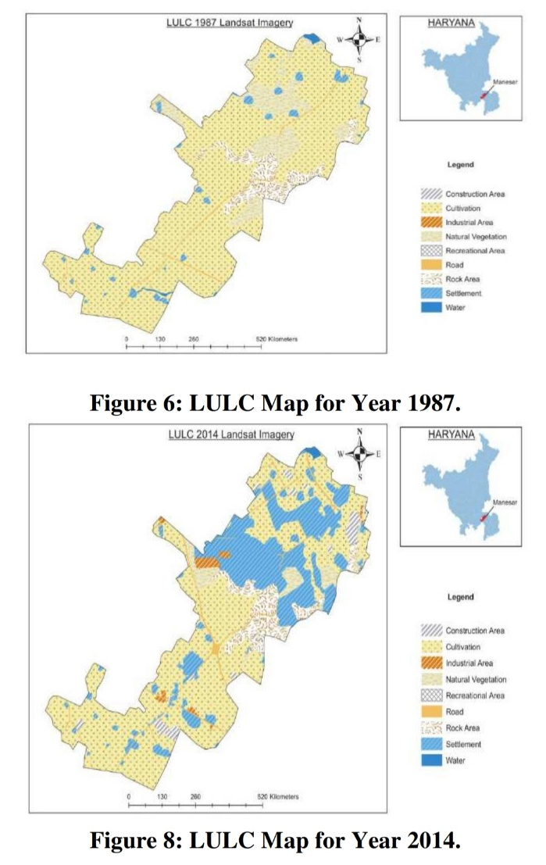

**Img(2): LULC Map of Year 1987**  **Img(3): LULC Map of Year 2011**

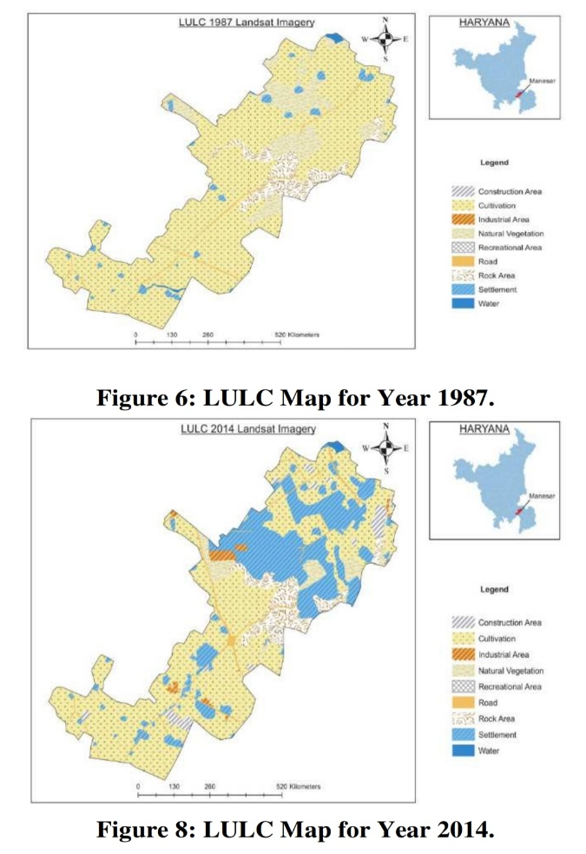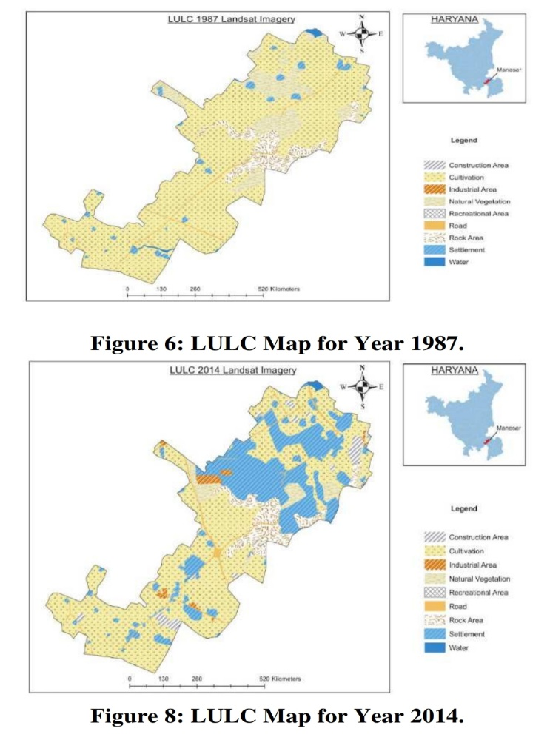

**Img (4): LULC Map of Year 2014 Img (5): LULC Map of Year 2019**

Population and Settlements:

Increasing infrastructure and projects results in the attraction of the immigrants and thus results in the large growing of urbanization and human population. The earlier data of 1987 and 2001 comprises of the district board and as per the record kept. As per Census report of 2011, The Manesar Tehsil comprises of 34 villages having a population of 116,606 with 440,74 household which have changed in the last past years. If we calculate the increasing past population using the “Geometric Growth Method” the project population of 34 villages will rise upto 515,500. This method suggests that the anuunal gowth rate of the population is 4.2% where as the decadal growth is 43.5% and is still in increase.

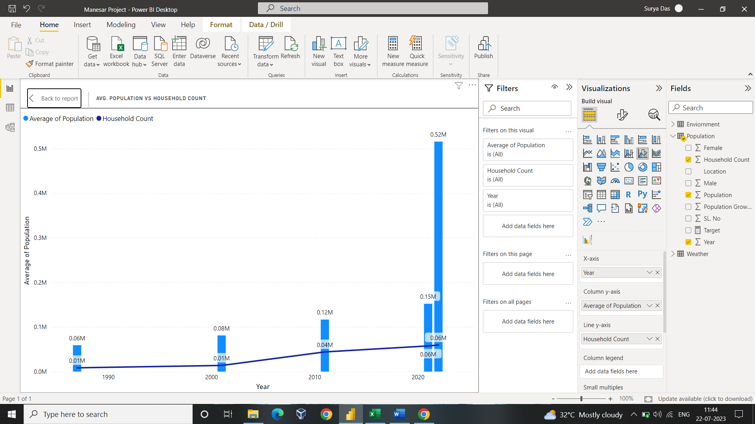

**Img(6): Analysis of Avg. Population vs Household Count**

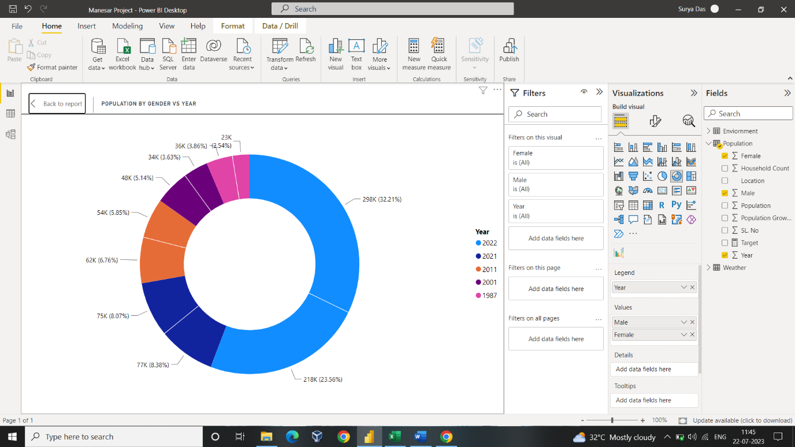

**Img(7): Male and Female Ratio of Each Year**

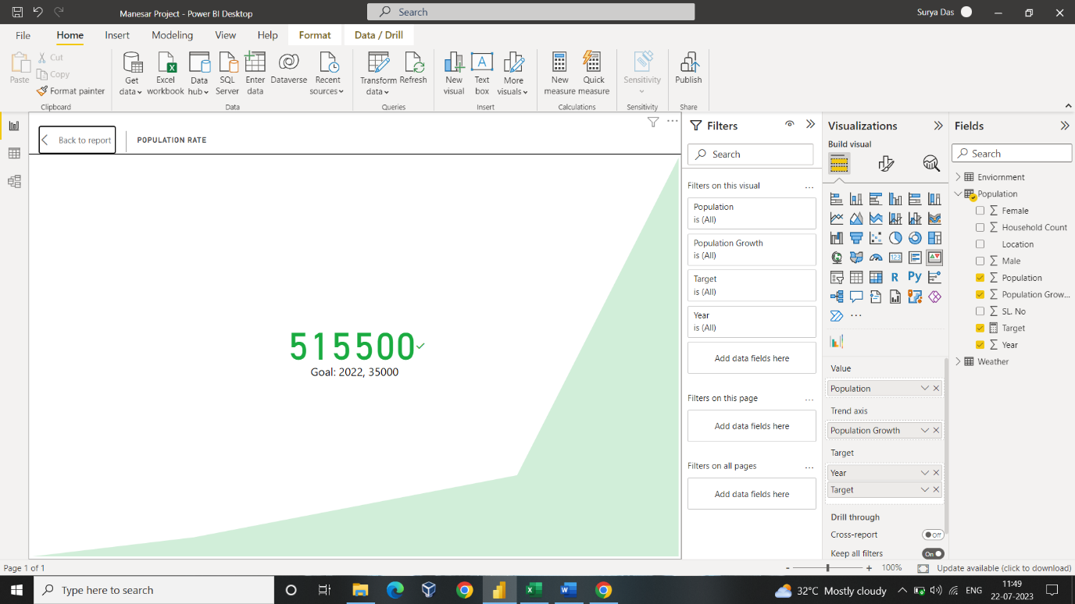

**Img(8): Population Growth scale**

Area Development: Population Growth Rate

Infrastructure and projects have been the major impact in the growth of population and increase in the settlement area. The urbanization and the development in the area around the given location gives a drastic impact in the temporal changes in the environmental factors such as temperature, rainfall, water storage and natural vegetation (Flora and Fauna).

The result of the development in the roads results in the increase in the transportation in the area in the recent years. Thus, this result in the increase in the automobilization which has effects in the environmental factors. Moreover, increase in the construction work and land urbanization results in the decrease in the natural vegetation of the cutting of trees, digging soil and making of roads. The agricultural land even gets effected due to this.

The Government in the recent two decades has planned to connect Metro rail to Manesar Network. A well-developed transportation network has resulted in the rapid development of infrastructure projects which also attracts many real estate players in the vicinity. Currently, the construction area has increased to 13% of the total study location.

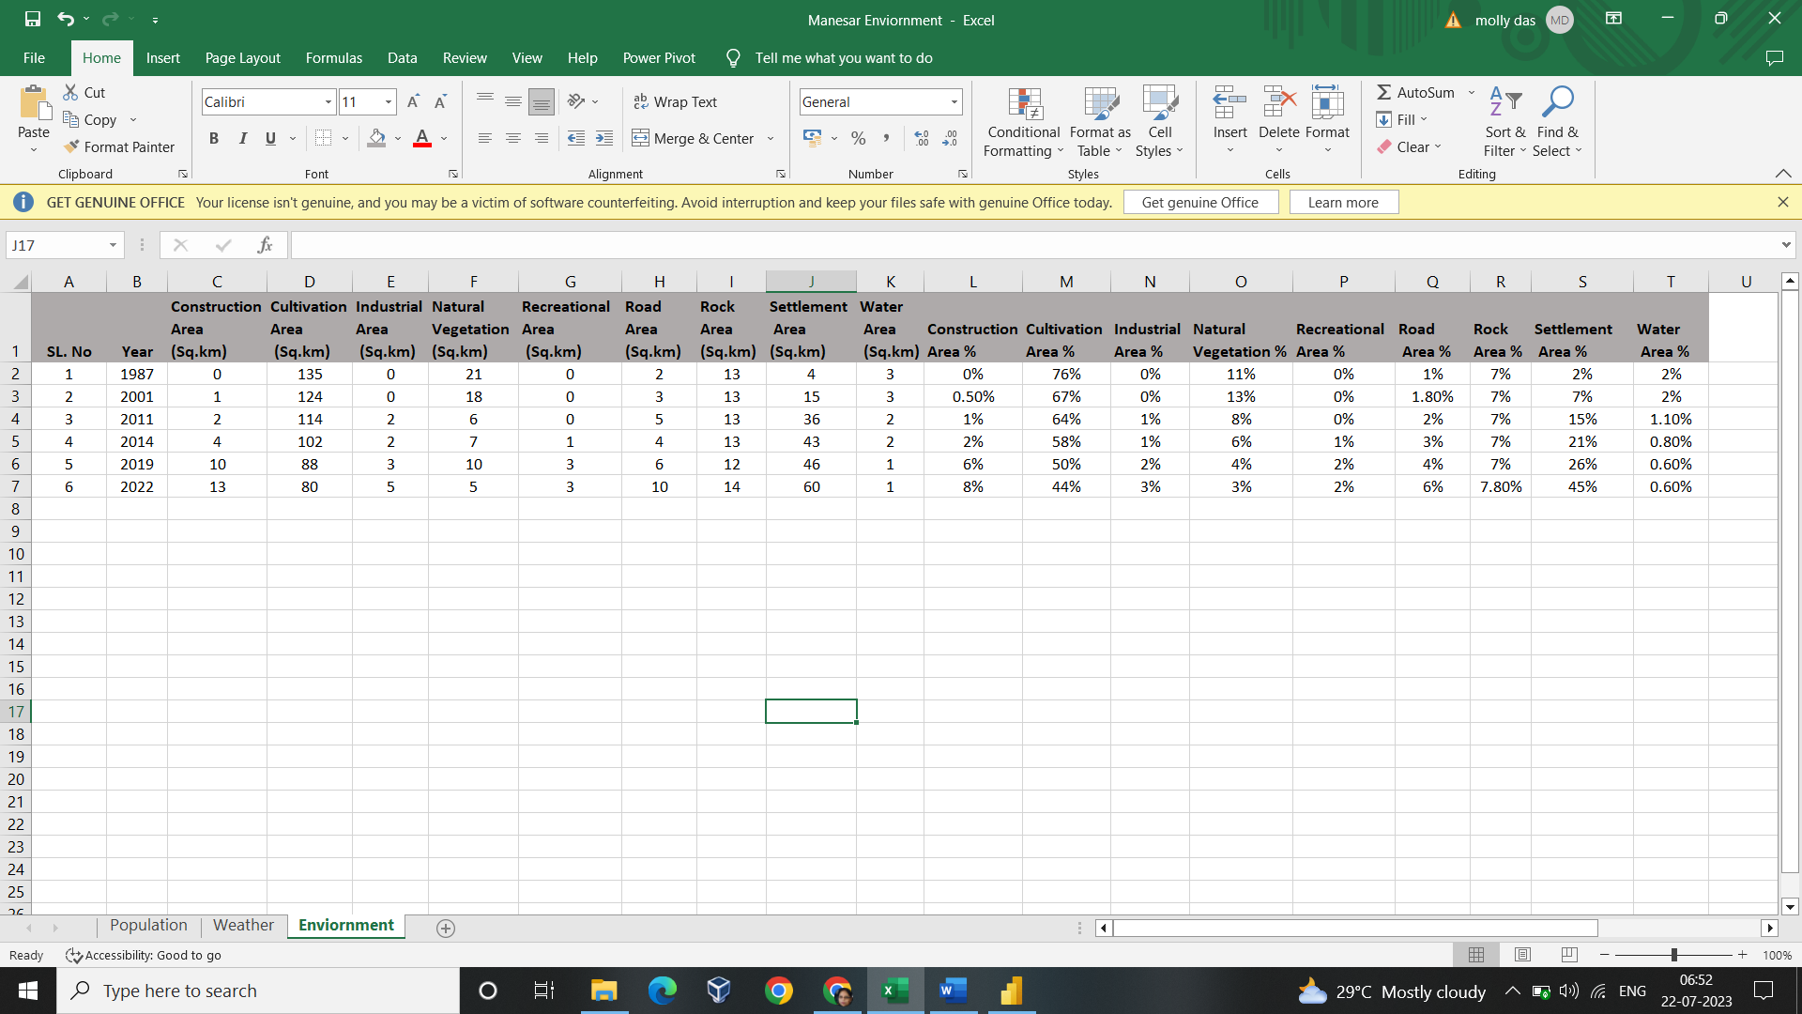

**Img(9): Area Development Data**

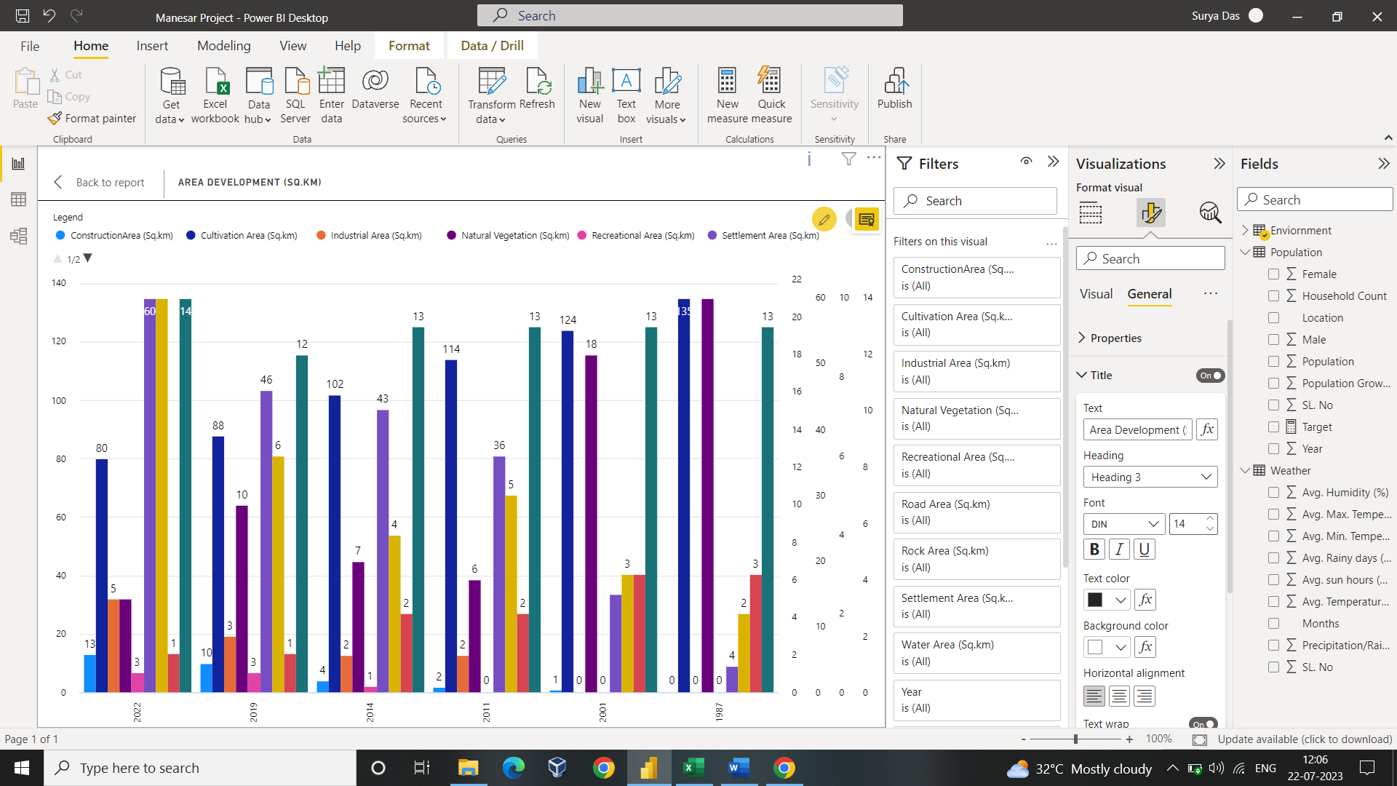

**Img(10): Analysis of Area Development Graph using Multi-Bar graph in Sq.km**

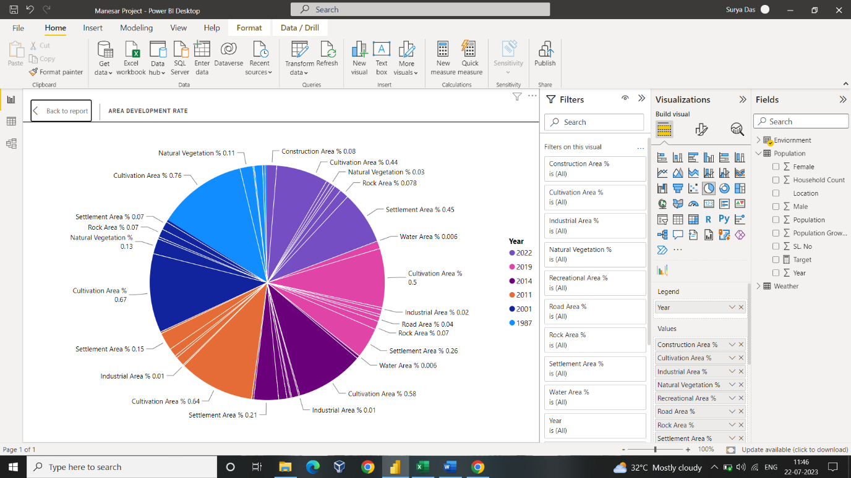

**Img (11): Rate of Area Development**

Temperature:

There is a huge temperature change in the recent two decades. The change in the temperature has drastic effects in the environment and the people living there. This temperature change results in the cutting of trees, pollution and urbanization. The Government has also raised high alerts in the changes in the temperature all over the world.

The data provided proves that rapid development in the field of urbanization and growth in the population results in the drastic changes in the temperature. The data here provided is of averagely counted from 1991-2022. The data contains Avg. Temperature, Avg. Temperature (Max. & Min.), Avg. Precipitation, Avg. Rainfall, Avg. Humidity and Avg. Sun hours on a monthly basis over these years.

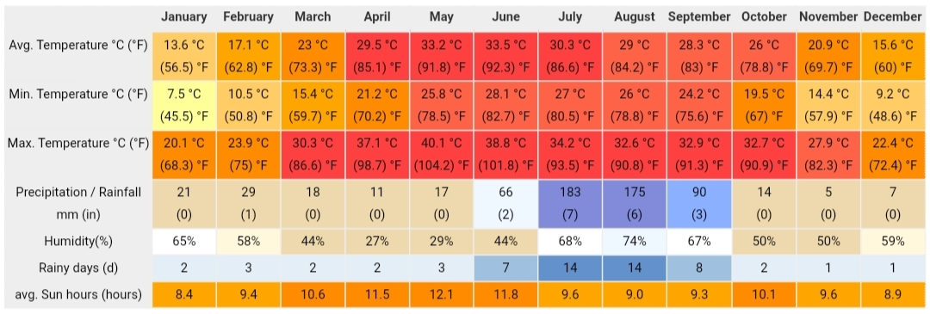

**Img(11): Weather Data**

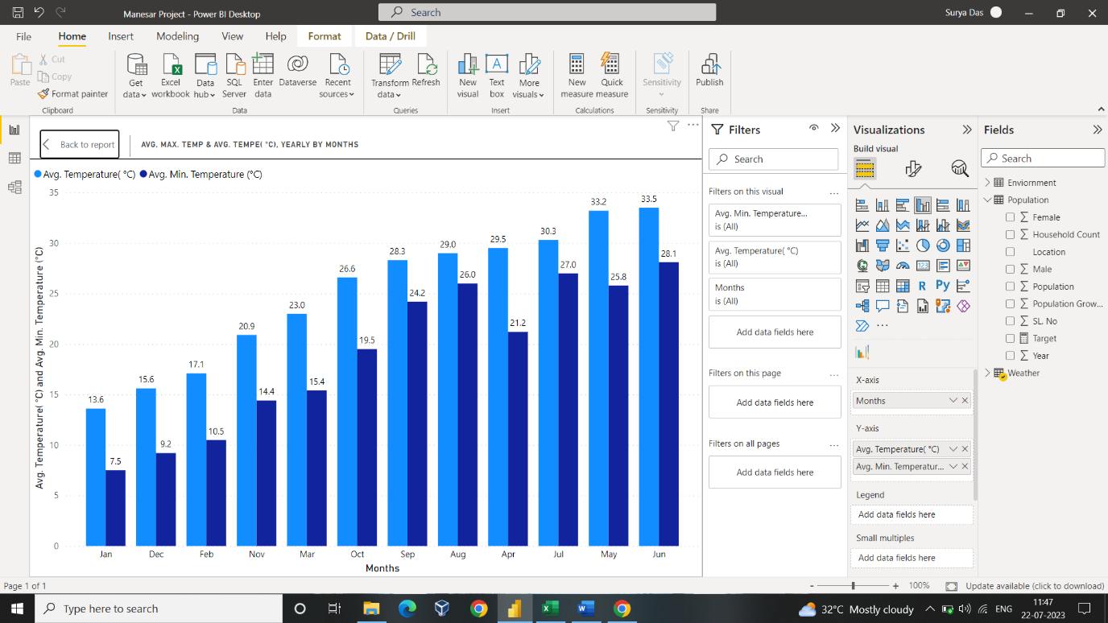

**Img(12): Analysis of Avg. Temp vs Avg. Min. Temp in (°C)**

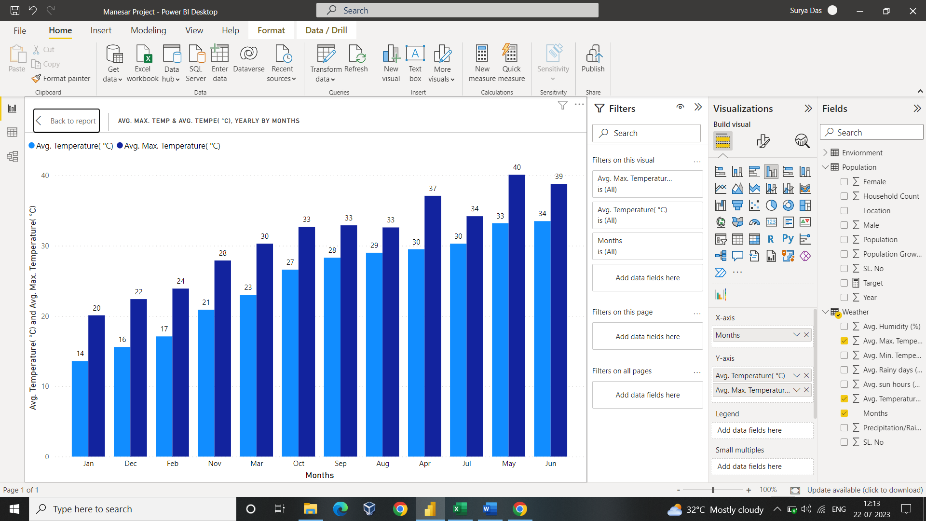

**Img (13): Analysis of Avg. Temp vs Avg. Max. Temp in (°C)**

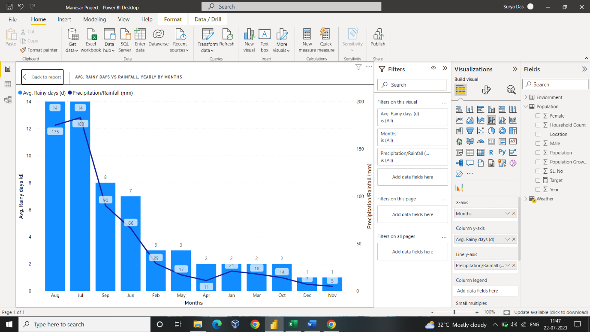

**Img (14): Analysis of Avg. Rainy Days vs Rainfall**

Natural Vegetation:

The natural vegetation data comprises of the Landsat image and from the year during 1996 to 2018. The image below shows there is very less natural vegetation in the provided location. Artificially cultivated lands are used by farmers for the growing of crops. There is huge amount of open land left for the settlement where construction is taking place these days. Moreover, area development rate has increased with the Government concerns and private companies.

Less amount tress and forest in the area is the result of increase in temperature and no natural water resources. Flora and fauna are simultaneous life cycles of nature. There is a very less and deep groundwater level. Dense vegetation is nearly visible in the area.

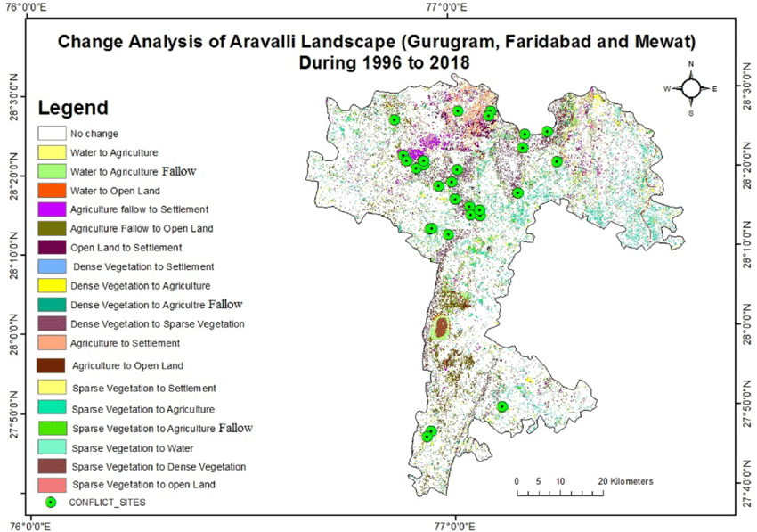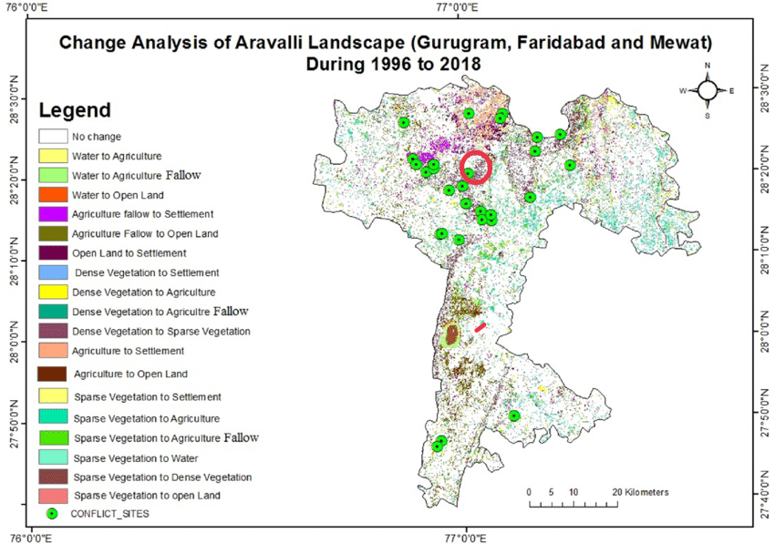

Manesar



**Img (15): The satellite image of Manesar Area with Natural Vegetation and Water Sources.**

Ground Water:

From the above image ground water is nearly visible to the naked eye. There are immensely deep-down underground water channels which is very less in count. The natural resources of water are negligible. Artificial water resources are in count of 2%-3%. From the above Img(15) we even get that there is a less count water as it is difficult to get through the naked eye.

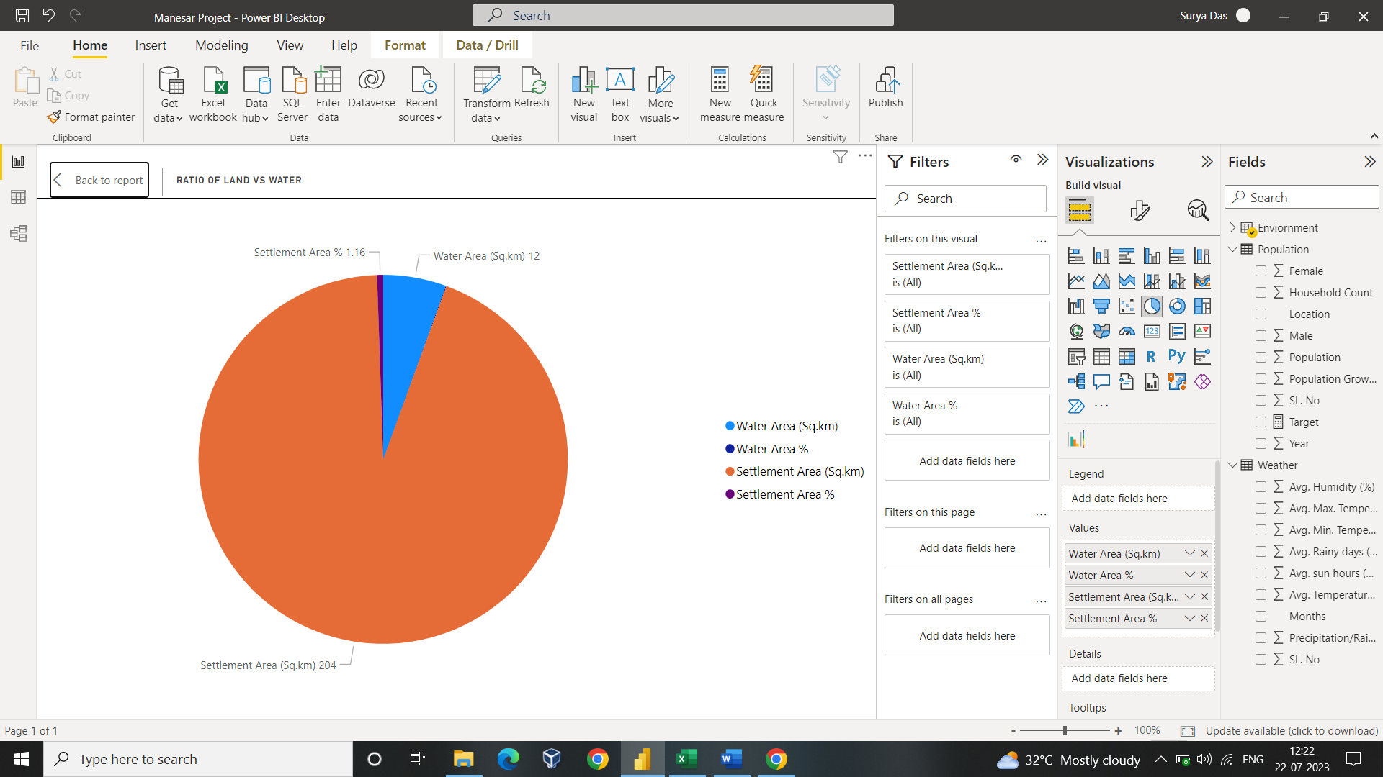

**Img(16): Ratio of Land and water around given location**

Conclusion and Recommendation:

Manesar Township as well as other villages across the tehsil will be expanding soon. Population density result in the high demand of water. Currently the ground water is worsening day by day at a level of 1.2 meter per year. There are much about planning and construction on the surrounding locations in Manesar. This development may increase environmental problems in the coming days in term of solid wastes. During the rainy season, the runoff from the hills can cause several issues. Due to large amount of transport route changes and railway connectivity there is a huge loss of land to farmers. A public-private hand to hand help might be the best way in reducing degradation in the environmental alarm rate slowly.

# References

|  |  |
| --- | --- |
| [1] | K. &. K. R. Suzanchi, ". Land use land cover change in National Capital Region of India: A remote sensing & GIS," *Procedia - Social and Behavioral Sciences,* Vols. 212-212, no. 10.1016/j.sbspro.2011.07.044, p. 21, 2011. |
| [2] | Asian Devlopment Bank, "NAtional Capital Region Urbanm Infratructure Financing Facility Tranche 2- – IMT Manesar Water Supply Project," October 214. [Online]. Available: https://www.adb.org/sites/default/files/project-documents//41598-026-iee-01.pdf. [Accessed November 2014]. |
| [3] | M. J. Manuj Dev, "Gis Based Temporal Analysis of Land Use Pattern And Its Impact Proposed Gurgaon Manesar Urban Complex," November 2020. |
| [4] | E. P. S. Ar. Manoj Panwar, *Critical Analysis of Land Use Planning along Kundli Manesar Palwal Expressway,* vol. Vol.6, no. 3 January 2016, 2016. |
| [5] | “. o. India, District Census Handbook-Gurgaon, New Delhi: Government, 1991. |